**SerDes VIP**

Table Of Contents

**1.** **Introduction to SerDes** 4

**1.1** **Introduction** 4

**1.2** **Configurations** 5

**1.3** **Features of SerDes** 5

**2.** **Testbench Architecture Of SerDes** 6

**2.1** **Testbench Architecture** 6

**2.2** **Components of Testbench** 7

**2.3** **Tx Flow of Testbench Architecture** 10

**2.4** **Rx Flow of Testbench Architecture** 11

Table Of Figures

**Figure 1 : SerDes Block Diagram** 4

**Figure 2 : Testbench Architecture Of SerDes** 7

1. **Introduction to SerDes**

## **Introduction**

The **Serializer/Deserializer (SERDES)** is a **high-speed data interface** used to convert data between **parallel and serial formats** for transmission and reception. In modern SoCs and communication systems, SERDES plays a critical role in **reducing the number of physical I/O lines** by serializing wide parallel buses, transmitting them over fewer wires, and then deserializing the data at the receiver end. A typical SERDES system includes a **transmitter (serializer)** that **converts N-bit parallel data into a serial stream**, and **a receiver (deserializer) that reconstructs the original parallel data from the received serial bits.** This is often synchronized across two different clock domains: **a parallel clock for system-level data and a high-frequency serial clock** for transmission.

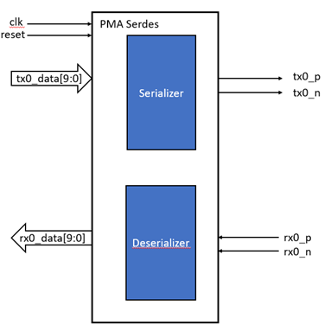

**Figure 1 : SerDes Block Diagram**

Serdes is a part of **PMA**. It has **2 blocks serializer and de-serializer**. **Serializer** will do the conversion of **parallel data to serial data** and **de-serializer** will do the conversion of **serial data into parallel data**. For Tx, the input data will be **10 bits parallel for single lane**, the **serializer will convert into serial data** and transmit on differential signal. **The baud rate for parallel and serial will remain same based on the speed selection**. Similarly for RX, the input data for PMA will be differential **RX signals** and **de-serializer will convert into the 10 bits parallel data**, here also the baud rate will remain same on both sides. **The clk and reset will provide as input to PMA.**

## **Configurations**

Here the supported configuration is **speed selection from 1G to 10G**, the variable no. of lanes, variable parallel data selection, **loopback support** in which rx data will not be captured, **low power mode in which the data and clk will be shut down** so the lines will be on high impedance state. **Here the differential signal indicates the polarity inverse of each other** i.e. **on p and n signals on serial side the data will be compliment of each other.**

## **Features of SerDes**

* High-speed serial operation
* Differential serial I/O
* Support for loopback
* Support for lane polarity inversion
* Low Power Mode
* Speed selection

1. **Testbench Architecture Of SerDes**

## **Testbench Architecture**

The SERDES VIP testbench is designed with a layered and modular architecture to provide thorough verification of **both parallel and serial data paths of the DUT**. The testbench consists of **four primary agents**: two for the parallel interface (one active and one passive) and two for the serial interface (one active and one passive).

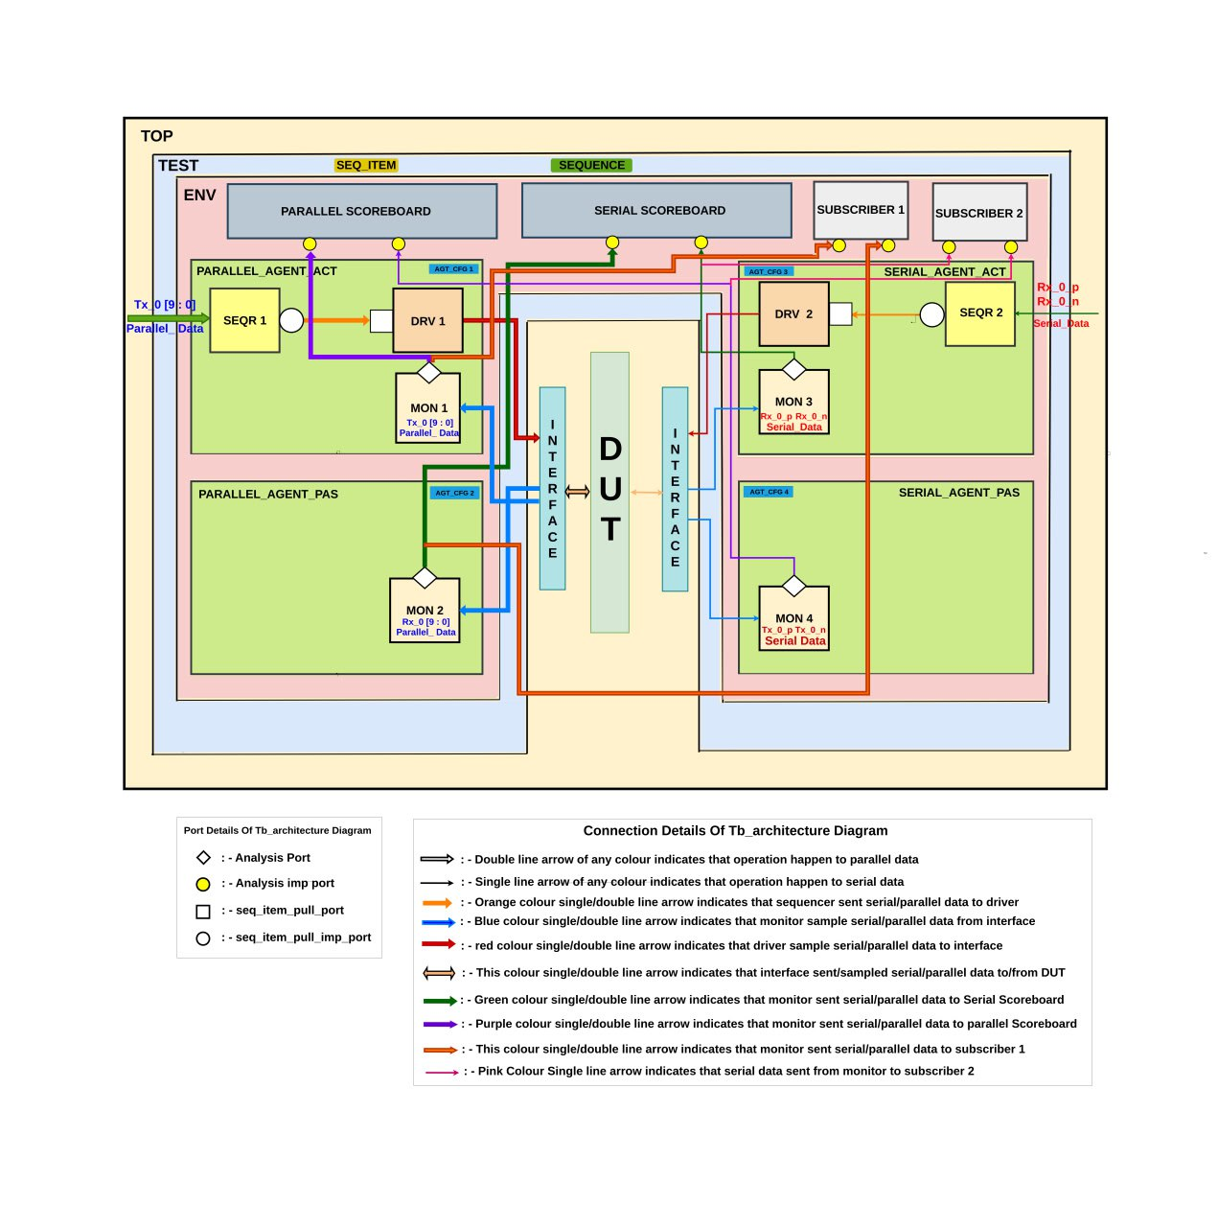

**Figure 2 : Testbench Architecture Of SerDes**

## **Components of Testbench**

* Top : The **TOP** block is the highest level of the verification hierarchy and coordinates the entire verification process. Its responsibilities include:
* Instantiating the **test**, which in turn creates the environment (ENV).
* Connecting the DUT with the verification environment through properly configured interfaces.
* Controlling the testbench clock and reset signals, including serial and parallel clocks.
* Providing DUT-level configuration parameters such as data widths, clock frequencies, and protocol options.
* Test : The test class is the entry point for executing any scenario. It is responsible for:
  + Instantiating and configuring the environment.
  + Creating and starting test sequences.
  + Overriding factory-registered components if necessary.
* Environment :
  + The environment (env) is a container class derived from uvm_env.
  + It instantiates and connects:
    - Parallel agent (active/passive)
    - Serial agent (active/passive)
    - Scoreboards (for both domains)
    - Subscribers
    - uvm_analysis_port for monitors → scoreboard/subscriber
* Agents : There are 4 agents Instance in SerDes VIP Architecture where two instance are parallel(Active and Passive) and two instance are serial(Active and Passive)
  + Parallel Agent : There are two parallel agents
    - Active Parallel Agent : It drives 10 bit parallel data Tx0 to interface and monitor that 10 bit parallel data using active parallel monitor.
    - Passive Parallel Agent : It monitor only parallel data Rx0 that is converted by deserializer.
  + Serial Agent : There are two serial agents
    - Active Serial Agent : It drives two 1 bit serial signals Rx0_p and Rx0_n to interface and monitor that signals using active serial monitor.
    - Passive Serial Agent : It samples two serial data Tx0_p and Tx0_n which is converted by serializer from Tx0.
* Agent_config : There is one agent_config class that is responsible to configure 4 agents parallel or serial and active or passive.
* Sequencer : There is two instance of sequencer one is known as parallel sequencer which send 10 bit parallel data Tx0 to driver and another one is serial sequencer which is send serial data Rx0_p and Rx0_n to driver
* Driver : There are two instances of driver first is parallel driver and second is serial driver.
  + Parallel Driver : Parallel driver drives 10 bit parallel data Tx0 to interface
  + Serial Driver : Serial driver drives two serial data Rx0_p and Rx0_n to Interface
* Monitor : There are 4 Instances of monitor two is parallel and two is serial
  + Parallel Monitor : It basically monitor parallel data only two parallel monitor in the testbench architecture one is active which monitor Tx0 and one is passive monitor which monitor Rx0.
  + Serial Monitor : It basically monitor serial data only two serial monitor in the testbench architecture one is active and one is passive active only monitors Rx0_p and Rx0_n and passive only monitor Tx0_p and Tx0_n.
* Scoreboard : There are two instances of scoreboard one for Tx side and one for Rx side
  + TX Scoreboard : It takes packet from active parallel monitor and passive serial monitor and compares both data.
  + Rx Scoreboard : It takes packet from passive parallel monitor and active serial monitor and compares that data.
* Interaface : The SERDES interface encapsulates all the necessary DUT I/O signals related to both serial and parallel domains, including:
  + Clocking (parallel_clk and serial_clk)
  + Reset signal (serdes_reset)
  + Parallel data signals
  + Serial data line
  + Modports for agent-specific access control
* Test_config : The test_config class is used to access test properties indirectly for example scoreboard required data of reset signal and transaction count.
* Sequence_Item: The serdes_transaction class extends uvm_sequence_item and acts as a container for a single transaction between the testbench and DUT. It represents one unit of data sent to or received from the DUT.
* Sequence : The **serdes_sequence** class extends uvm_sequence and is used to generate multiple serdes_transaction objects and send them through the sequencer to the driver.

## **Tx Flow of Testbench Architecture**

The **Transmit (TX) flow** in the SERDES VIP testbench architecture describes how data is generated, driven, and transmitted from the **parallel domain** to the **serial domain** through the serializer block of the DUT. The VIP components collaboratively enable functional verification of this data path.

**Sequence Item Creation**

* The sequence item (e.g., serdes_transaction) is extended from uvm_sequence_item.
* It contains the Tx0 field representing the 10-bit parallel data to be serialized.
* Randomization or directed values are generated in this transaction.

**Sequence Execution**

* The serdes_tx_sequence starts on the Parallel sequencer (seqr1).
* The sequence generates and sends one or more serdes_transaction objects using start_item() and finish_item() calls.

**Sequencer-Driver Communication**

* The parallel sequencer passes each transaction to the TX driver through the seq_item_port.
* The parallel driver receives the transaction using get_next_item() and processes it.

**Driver Behaviour**

* The parallel driver drives the transaction’s parallel data (Tx0) to Interface.
* Using the interface (serdes_interface), it drives parallel 10 bit data to serializer dut
* The transmission of parallel driver is synchronized with parallel clock.

**Interface Role**

* The serdes_interface binds both the serial and parallel clocks (serial_clk, parallel_clk) and data lines.
* It provides a structured way to connect VIP drivers to the DUT using modports and clocking blocks.

**DUT Serializer Function**

* The DUT receives the 10-bit parallel input (Tx0) and serializes it into 10 serial bits.
* It transmits one bit per cycle on the serial_data line during each rising edge of the serial_clk.

**Monitoring**

* The parallel active and passive monitor observes the parallel input (Tx0) and parallel output (Rx0).
* It publishes transactions via an analysis port to the scoreboard and subscribers for checking and logging.

**Scoreboarding**

* The Tx Scoreboard takes data from Active Parallel Monitor and Passive Serial Monitor.
* Passive Serial Monitor convert that serial data into parallel data and send into the scoreboard.

## **Rx Flow of Testbench Architecture**

The **Transmit (RX) flow** in the SERDES VIP testbench architecture describes how data is generated, driven, and transmitted from the **serial domain** to the **parallel domain** through the deserializer block of the DUT. The VIP components collaboratively enable functional verification of this data path.

**Sequence Item Creation**

* The sequence item (e.g., serdes_transaction) is extended from uvm_sequence_item.
* It contains the Rx0_p and Rx0_n field representing the 1 bit serial data.
* Randomization or directed values are generated in this transaction.

**Sequence Execution**

* The serdes_rx_sequence starts on the Serial sequencer (seqr2).
* The sequence generates and sends one or more serdes_transaction objects using start_item() and finish_item() calls.

**Sequencer-Driver Communication**

* The serial sequencer passes each transaction to the RX driver through the seq_item_port.
* The serial driver receives the transaction using get_next_item() and processes it.

**Driver Behaviour**

* The serial driver drives the transaction’s serial data (Rx0_p and Rx0_n) to Interface.
* Using the interface (serdes_interface), it drives serial 1 bit data to deserializer dut.
* The transmission of serial driver is synchronized with serial clock.

**Interface Role**

* The serdes_interface binds both the serial and parallel clocks (serial_clk, parallel_clk) and data lines.
* It provides a structured way to connect VIP drivers to the DUT using modports and clocking blocks.

**DUT Deserializer Function**

* The DUT receives the 1 bit Serial input (Rx0_p and Rx0_n) and deserializes it into 10 parallel bits.
* It transmits 10 bit per cycle on the parallel_data line during each rising edge of the parallel_clk.

**Monitoring**

* The serial active and passive monitor observes the serial input (Rx0_p, Rx0_n) and serial output (Tx0_p, Tx0_n).
* It publishes transactions via an analysis port to the scoreboard and subscribers for checking and logging.

**Scoreboarding**

* The Rx Scoreboard takes data from Passive Parallel Monitor and Active Serial Monitor.
* Active Serial Monitor convert that serial data into parallel data and send into the scoreboard.